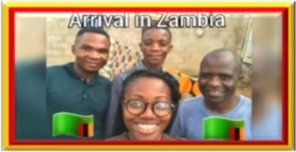
Okay, guys, I’m finally in Zambia with Pastor Chama and Pastor Brian. I want to show you what Africa looks like. Everyone has a bad perception of Africa, and we are here, a Zambian Mall.
So, I am so exhausted — I’m tired — we’re headed now to where I will be staying which is ten hours away. So signing out until later.
~~~
11 HOURS LATER IN SAMFYA
~~~
At the beautiful Lodge they booked for me
But St Francis wasn’t having it…LOL
You’ll find out in the next video…
~~~
So, I finally to the city of Samfya [SAM-fi-a]. Pastor Chama put me up in a lodge called Samfya Lodge right next to the beach which is probably not very Franciscan. I really, really tried to stay in the village with him, but he has a wife and children Vlog No. 1 In Zambia - My Arrival - Draft 1and so does Pastor Brian. They thought it would be best for the community, the village community, to get to know me first before I try to impose myself on some family to stay with them. So, I had to stay at a place that is about an hour away from where he stays. So it’s going to be a long haul every single day, coming here to get me and take me back to the village to do things. We’ll see how the Lord works it out.
So, it was about a twelve-hour drive, my goodness. I know they are so exhausted. The Lord gave some natural grace for us to get here but, guys, it’s beautiful. He told me the name of this lake, I just can’t remember it. He said the story is that some guy saw the lake and thought, wow, it’s beautiful. If you look at it, it says the story behind it is he saw the lake and it seemed like the lake touch the sky. So in his language it’s about the lake touching the sky — like it never ends. It looks like that too — it looks like it never ends. It is so beautiful, my goodness. Zambia is so beautiful. I just love Africa and I’m excited to see what the Lord wants to do here — and why I’m here. So, I’m not sure, I still haven’t received that annunciation yet but once I do I’ll definitely vlog it so you guys will know as to what the Lord wants to establish here. So, we’ll keep you posted.
All right, thank you guys. Love you all, bye

