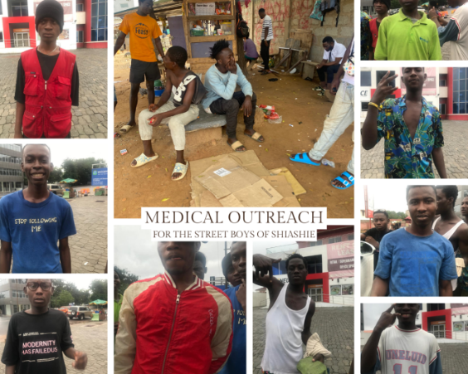

Hello brothers and sisters and Heartdwellers family. This is a video updating you on our weekly outreach and the impact your donations have made in the lives of these precious few. The Lord keeps playing the song the Cry of the poor and we know his heart is for us to meet the needs of the poorest of the poor and the suffering and we get to do a little bit of that every week. In partnership with Happy care global our vision is to open a soup kitchen led by the organization to help facilitate a more orderly and larger scale feeding ministry. So please pray for that as they are raising funds to get a building and equipment in the meantime they help us with the outreach every week.

We gather at Antoinette’s house and we cook local dishes. We have now outsourced two of the weeks to patronize small business by having them cook the meal for us then another two weeks where we personally cook for them. We pray as we cook and sometimes we forget but we pray over the food afterwards. Initially we wanted to really ministry to the children and the Fulani Muslims but the lord put it on our hearts that it was the young men he was after. There are about 60 of them that all come from the same village to the city capital Accra Ghana to make a living from themselves by cleaning windows.

The purpose of this video today is to give you insight not only to the outreach but inside into how they lives .They don’t make much at all and many have various health conditions we found out. Here is Mahama a young man explaining his skin condition and wound he incurred through a motor accident. and Here is a picture of a few of the boys. We couldn’t get them all on camera but they revealed to us what their medical condition was –

Michael - pees blood   
Kwame - heart hurts when he runs, pees blood  
 Prince - feels his heart pulling at times   
Nathaniel- feels pain when urinating, feels chill (smokes weed and cigarettes)   
Michael Dede- at night gets chills ( smokes weed and cigarettes)   
Richard Tetteh - feels pain, and has blood in urine , penis burns   
Ibrahim Mohammed- coughs, spits blood ( smokes weed)   
Bismark - got hit by a motorbike 8nights, has headaches and jaw pain , broken teeth pain   
Marcus- hernia , has been to doc   
Sarpel- hurts when pees, after pooping he has white discharge   
George, Mahama, Musa & Richmond- their heart hurts and so does Abikeu, who we found out is expecting twins and you will meet his lovely girlfriend in the next video.

These are some serious needs and the Lord is asking us to start a go fund me campaign to raise $5,000 to work with a local doctor by the name of Dr. Tamakloe who is a neuro surgeon. He a clinic in the US for sometime until he moved to Ghana for good to start his private and now general practice clinic. Here is a little trailer of a medical outreach he did for his birthday**.**

We want to partner with him and his medical team to do a medical treatment outreach for the boys. They will receive free lab test and we will get free basic medication so we can not only diagnose the issue but treat the most serious cases properly. And here is some footage of the boys living conditions. They live in an empty yard with many others and sleep on the cardboard boxes on the floor. When it rains they get drenched and are looking to build a shed for covering. It cost around $140 to rent the plot area where they sleep and there’s also additional costs to get building material to build the shed, so we are working on that now.

So family please continue to support us and this GoFundMe campaign so we can make this medical treatment happen for them and build the shed . Our hearts desire is that they would come to know the love of the Father. Please pray for their hearts to be really open to receive our words and the Lords love for them and pray for us for anointing to draw them all closer to Jesus to not only meet their physical needs but the need of their soul by the grace of God. Thank you family for your support and donations.

God bless you, until the next message.

If you would consider sharing or donating to the GoFundMe, Medical Outreach for Street Boys https://gofund.me/018117f5