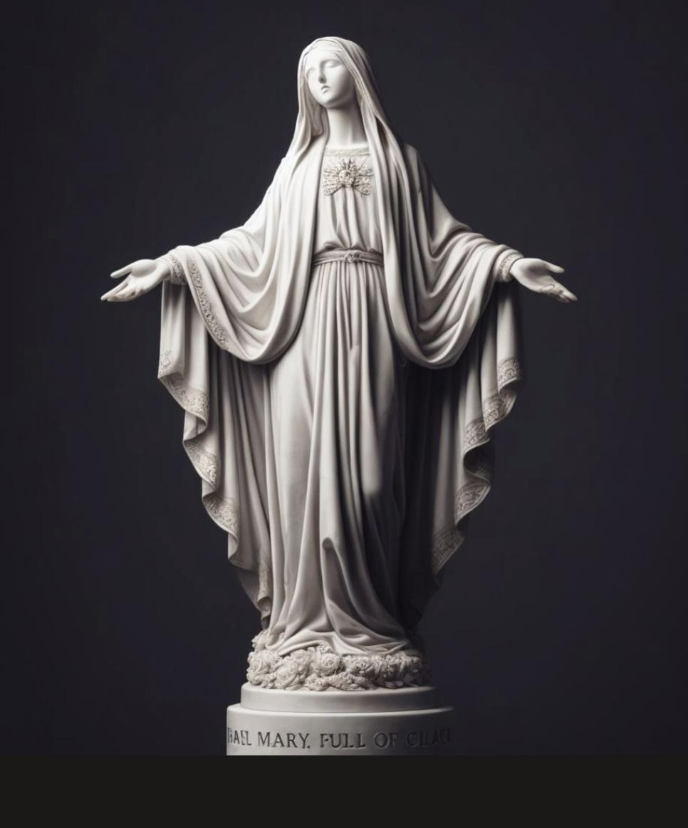

Thank you Lord for your great mercy towards me, thank you for humbling me and thank you for growing me in greater trust in you.

Jesus, what is on Your heart his morning ?

**Jesus began,**

“*You have done well to submit yourself and all things to My Mother. She is faithful and her intercession carries so much weight and fruit. Tell your cousin to do the same, and what she has been unable to do in prayer with all her fasting and sacrifice, My Mother can do in one word by saying, Son if not now, when?”*

As an aside - the Lord is referring to my cousin who has been going through a very difficult situation for a whole; and she’s very open now to the Saints and the intercession of the Saints and The Blessed Mother. I gave her, her first Rosary last week and encouraged her that I would help her to learn how to pray the Rosary.

And the saying Jesus mentioned - “Son, if not now, when?” is referencing to The Chosen series. Which is a tv series about his life and the life of the apostles. It was a scene during the wedding of Cana where they were out of wine and His mother came to inquire if he could help and Jesus said it wasn’t His time yet just like in scripture and her response was: If not now, when? She simply spoke to the servants to do whatever Jesus told them and sure enough, Jesus turned the water into wine.

It’s amazing to know the influence His Mother has because all through-out scripture, Jesus did nothing except what the Father did. And He would often tell his disciples that it wasn’t His time yet. Or when the Pharisees wanted to harm him, the scripture would say they couldn’t do anything to him because it was not yet time. Yet when His Mother asked, although it wasn’t his time, as He had said several times before; the Father was moved, and allowed Jesus to work a miracle before the appointed time just because it was His Mother who asked.

**John 2:1-11:**

**On the third day there was a wedding at Cana in Galilee, and the mother of Jesus was there. 2Jesus also was invited to the wedding with his disciples. 3When the wine ran out, the mother of Jesus said to him, “They have no wine.” 4And Jesus said to her, “Woman, what does this have to do with me? My hour has not yet come.” 5His mother said to the servants, “Do whatever he tells you.”**

**6Now there were six stone water jars there for the Jewish rites of purification, each holding twenty or thirty gallons.[**[**a**](https://www.biblegateway.com/passage/?search=John%202%3A1-11&version=ESV#fen-ESV-26091a)**] 7Jesus said to the servants, “Fill the jars with water.” And they filled them up to the brim. 8And he said to them, “Now draw some out and take it to the master of the feast.” So they took it. 9When the master of the feast tasted the water now become wine, and did not know where it came from (though the servants who had drawn the water knew), the master of the feast called the bridegroom 10and said to him, “Everyone serves the good wine first, and when people have drunk freely, then the poor wine. But you have kept the good wine until now.” 11This, the first of his signs, Jesus did at Cana in Galilee, and manifested his glory. And his disciples believed in him.**

“*Her love, her Humility and Her heart gets Me to move just as I did for you before the appointed time. My Mother speaks and I work miracles on her behalf to bring Her great honor and a share in My glory. Yet so many of My brides and believer do not understand. I have chosen you tell them beloved. Do not shy away from the opportunity tell others about the power of My Mothers intercession and her intervention in your life*.”

And it’s so true, I have been going through it family for the past week. Everything had been going good between me and this soul. However, I began to see several 555’s and it started making me anxious. I began to have bad dreams of accusation and suspicion, which greatly heightened my anxiety and the enemy pounced in with fear, because I had received a warning from two different servants of God, that a trial was coming for us. We all know as Heartdwellers, even leading up to Halloween is difficult and the time after, because of the many curses released. So it first started with a little misunderstanding, then arguments that weren’t being resolved and rather left me rejected, abandoned and not heard. Which further magnified my old habits of worry and trust issues. The same time last year this happened, and it led to the most painful trial of my life, which lasted for 7 months. I was paralyzed in fear, crippled actually with hopelessness and despair wondering if this what they had warned us about and if I would be able to endure through something like that again. It even took away my desire for prayer as the enemy reminded me: what was the point? I did the same thing last year and all my fears still happened. I didn’t know where to turn and last night I gave up the fight as I got the Rhema:

***“Do not worry just lay it down its not your fight… I am right on time*”**

As I was still seeing so many 555 songs about suffering, readings on the passion, it was in my face at every turn – that I began to resent even the Lords warning of the trial I was in and more to come, because it caused greater fear and anxiety. So I prayed the Rosary very sincerely for the first time in a while, in a place of total surrender and helplessness, saying whatever the Lords wills that Mother should give me grace to endure through it however long and help me through this. Then I said a simple request in my heart for this soul to do something very specific, and to sincerely show an act of thoughtfulness, compassion and care towards me, by coming to spend time with me which we hadn’t really done in a while without tension and pain.

Right afterwards, as I just wiped my tears, the soul came; not only apologized, but did everything I had asked Mother for in my heart. The souls heart had changed towards me in the most tender way and where I thought I was looking at an uphill battle of pain and tears for however long, ended just like that. Melted away like ice like Jesus said all obstacles would.. wow. I was so amazed, then remembered the power of her intercession and how I had desired breakthrough, prayed for it and I hadn’t really gone to her for help or sincerely given it to her and when I did, a miracle took place, for me anyway. I felt something finally broke.

**Jesus continued,**

“*She is the one who has obtained the grace for you for deliverance from your enemies and deliverance from the trial you were in. You did not lose any virtue or grace because your trial was shortened but rather gained*. “

Wow Lord when I saw the rhema bout being patient, strong and courageous I was tormented that this trial would be a long one and last going on for months like last year. The fear gripped me and I was paralyzed with sorrow and sadness unable to think clearly and wondering if I would be able to endure such another trial.

“*The cup intended for you would’ve indeed been one of long suffering giving you much time to grow in those virtues stated, but when you prayed the rosary yesterday in tears she heard the cry of your heart and your cry became Hers and Her cry became mine and the Father relented because of it and in a moment your prayer was answered. So you see the fruit and power of the rosary.*

*That is not to say that every time your prayers would be responded in this way there are times rather than the trial being shortened you are given tremendous graces to not only endure but to have a peace that passes understanding in the midst of it and My joy that is supernatural as you wait for your salvation and that is also obtained for you by Her through your intercession.*

*She always seeks to align herself with the will of the Father in all things and she does because she is so one with Him too. However, she is also a Mother and what Mother would not be moved to pity and compassion when one of her children is suffering something beyond their capacity they feel they can no longer bear. Your sufferings becomes her sufferings your tears become her tears and when you call on her through the rosary she will move on your behalf to give you a miracle so thank her profusely beloved*”

Thank Mother so much for your tender care, your attention to every detail of my life and your concern in the movements of my heart that caused you to move on my behalf thank you Mother. I always say I don’t come to you as much make me a better daughter I give you everything and leave everything in your blessed Immaculate hands for you can do wonders with the gravest of cases Oh Mother thank you I love and honor you!

Blessed Mother, Our Mother of Mercy began,

“*I’m here my dear little one, I am here (smiling)  
 Be faithful to pray the rosary daily My dear children, very faithful. There is nothing that God will not do to come to the aid of the cry of His little ones. I am here to assist and aid in this life and in the next. Be faithful to pray the rosary little one for your trip everyday leading up to it and when you are there. Do not concern yourself with your beloved. His heart is changing beautifully only if you could see from Heaven perspective. In time great light and truth will be shed abroad in His heart concerning My role to him and My role in the church. For now it is safe again to share your love of Me and the power of the rosary to others that My son may be glorified all that the more.*

*My beloved ones, these are such grave times of testing, offering and sacrifice. Yes, Jesus is asking for everything until the last drop and you can give everything I mean everything to Me. I will continue to make your filthy rags into precious piles of righteousness. Is there a trial, a struggle, a sin, an addiction or a habit you have been struggling with for a long time? Give it to Me. Trust Me as you pray the rosary relinquishing all to Me that I will handle it. Is there a situation that has been a long standing circumstance of confusion, of pain, and you are not seeing any breakthrough?*

*My beloved children give that situation to Me in the rosary, and I will work a miracle for you. You have only but to surrender into My Motherly hands asking for My assistance, My intercession for God to move on your behalf, that stubborn mountain or that giant that stands in your way. And even if its not the appointed time for your salvation and deliverance because I have prayed and present your request before the Father, He moves on your behalf, just as He did at the wedding of Cana.*

*The favor given to Me is not of My own doing, but the goodness of the Father to give me the ability to sustain all the graces given to me and to walk in great humility imitate My son and completing entirely the work He had called Me to do when I was on Earth because of that I speak and He listen and His heart moves to come to the aid of the one I am petitioning. So you see beloved ones many of you are in sufferings and trials that have been weighing you down with much burden. Give it to Me, your Mother ask Me for help and aid and breakthrough will come.*

*Continue My little one with the inspiration given to you, you must be more disciplined and faithful with your time. There is much to do and to accomplish before you leave and much preparation that I will be doing on your behalf as you pray for what the Lord desires to do in these nations with the groups and people you will meet*

*Do not fear bring my rosaries into China, use wisdom and pray over them as well. I will ensure there will be no hiccups or issues trust me beloved little one as the many who have come before you have trusted in God to make them sometimes even invisible to their enemies. This is all preparing you for greater trust in the Lord you must have when your sent to dangerous territories or put in tenses situations you will not fear sharing the gospel and will come up with creative ways to do. You have Gods protection all of Heaven and the angels with you and behind you do not fear and move forward in these things”.*

**And that was the end of the message.**

God bless you family, until the next message.